**Project Report Template**

1. **INTRODUCTION**
   1. **OVERVIEW:**

Electric Vehicle gives the information about the vehicle charge and range analysis and we have to present a charts for the given data

**1.2Purpose:**

A vehicle that can be powdered by an electric motor that draws electricity from a battery.

1. **PROBLEM DEFINITION & DESIGN THINKING**

Brainstroming map:

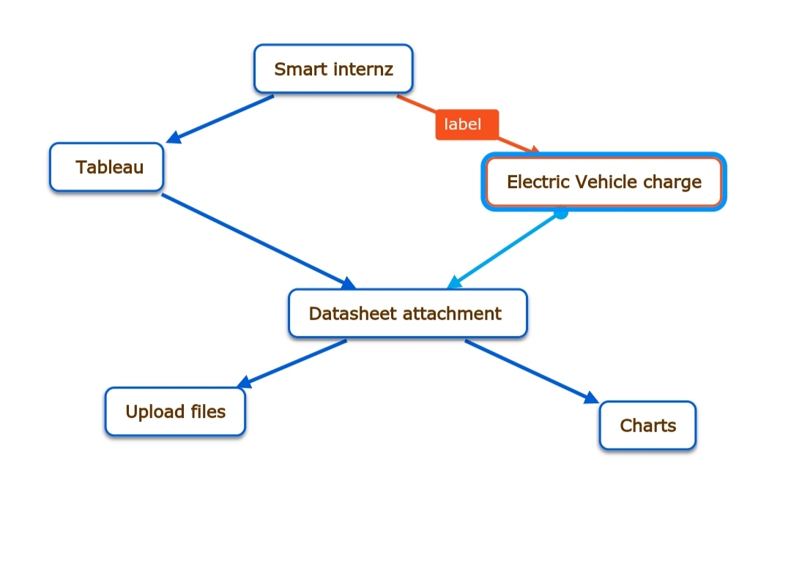

Empathy map:

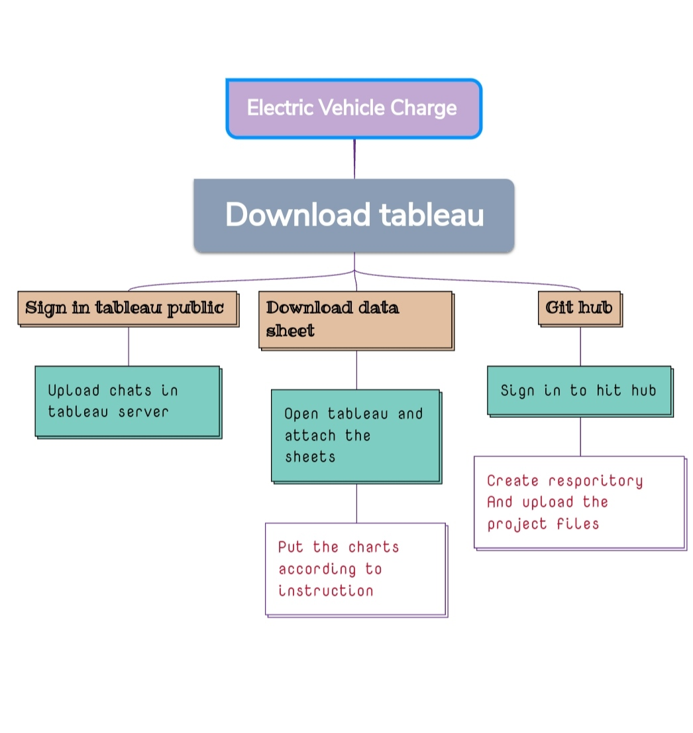

**RESULT**

Output of the project

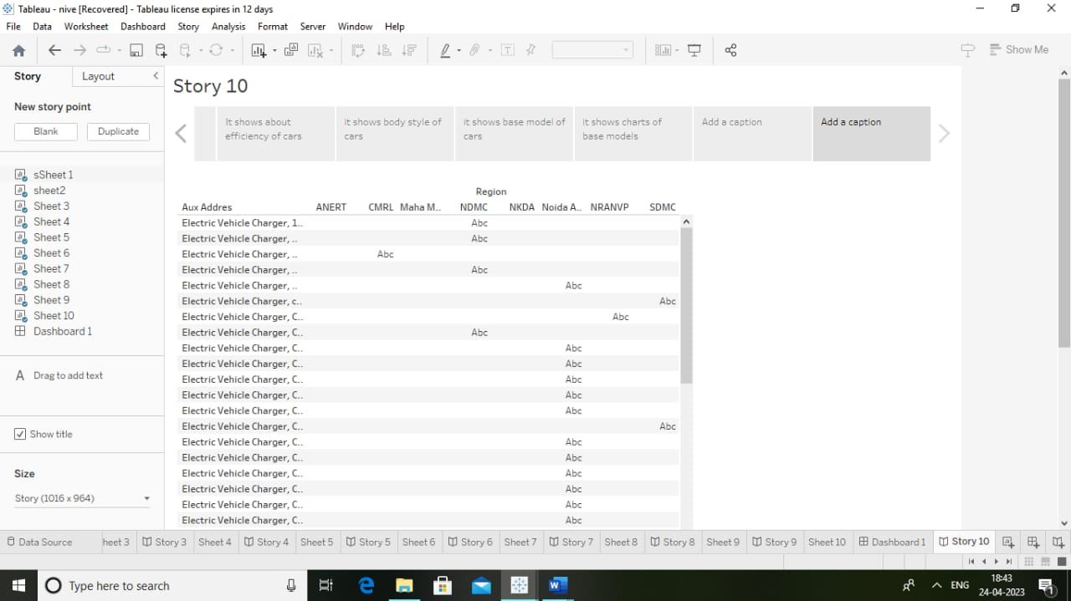

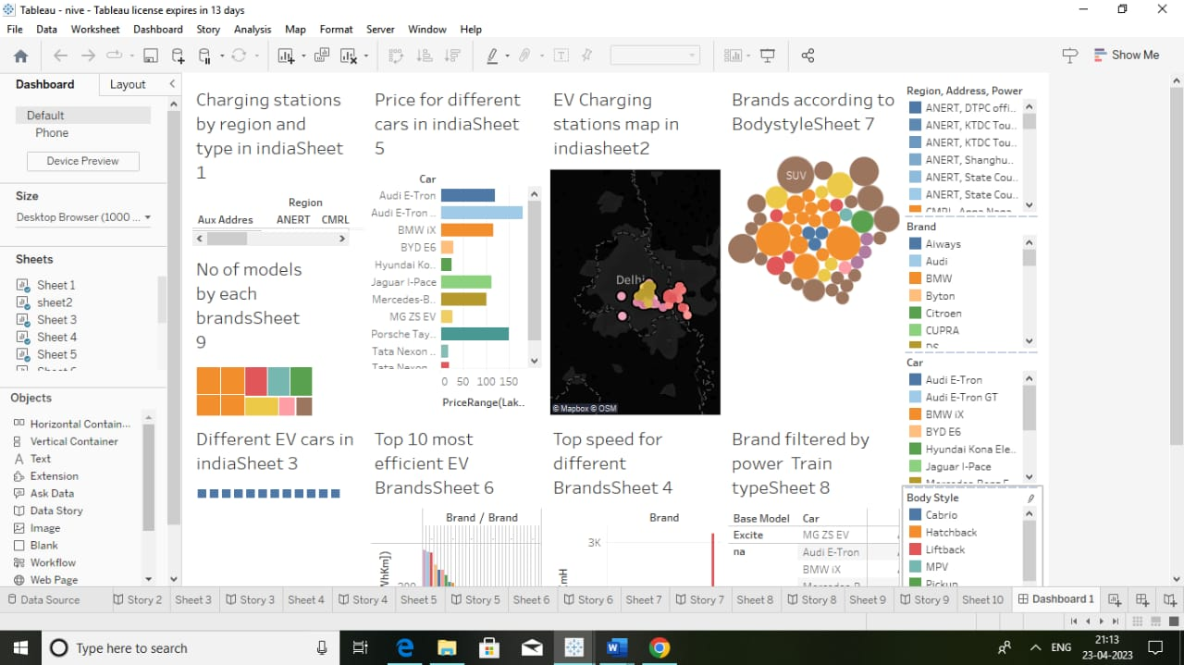

**ADVANTAGES :**

* By doing this project we have gain knowledge about the vehicles

**DISADVANTAGES:**

There is a some server problem in crating the project

**APPLICATIONS:**

* We can use this analysis in motor Industry

**CONCLUSION:**

Atlast I conclude that by doing this project I have gain knowledge about motor vehicles usage